

CP Lab-10 Tasks

Name: Syed Muhammad Raza Ali

Enrolment: 02-134231-028

Course: CP Lab

Faculty: Miss Fatima

**Lab 10 String**

**Tasks: 01**

Write a program that determines if a string contains a certain alphabet and its number of occurrences. It displays ‘Not Found’ if the letter is not found in the string. Be sure to take case of the case sensitiveness.

Code:

#include <iostream>

#include <string>

using namespace std;

int main() {

int c = 0;

bool flag = false;

char searchElement;

string input;

cout << "Enter a string ";

cin >> input;

cout << "Entrer the alphabet you want to search ";

cin >> searchElement;

for (int i = 0; i<= input.length()-1; i++){

if (input[i] == searchElement){

c = c + 1;

flag = true;

}

}

if (flag == true){

cout << "alphabet found! occurences are " << c<<endl;

}

else{

cout << "alphabet doesn't exist" << endl;

}

return 0;}

Output:

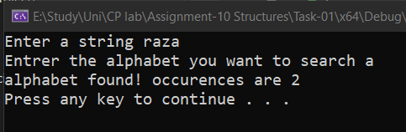

**Tasks: 02**

Write a program in C++ in which we will get an input from the user and check whether number is palindrome or not.(use customize function)

Code:

#include <iostream>

#include <string>

using namespace std;

int main() {

string input, reversed;

cout << "Enter a string: ";

cin >> input;

for (int i = input.length() - 1; i >= 0; i--) {

reversed+= input[i];

}

if (input == reversed) {

cout << input << " is a palindrome" << endl;

}

else {

cout << input << " is not a palindrome" << endl;

}

return 0;

}

Output (if palindrome):

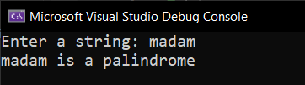

Output (if not a palindrome):

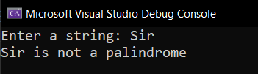

**Tasks: 03**

Write a program that compare two strings and prints the shorter one. It prints equal if both strings are same.

Code:

#include <iostream>

#include <string>

using namespace std;

int main() {

string word1, word2;

cout << "Enter a sting" << endl;

cin >> word1;

cout << "Enter another string " << endl;

cin >> word2;

int a = word1.length();

int b = word2.length();

if (a == b) {

cout << "both string have equal lengths " << endl;

}

else if (a > b) {

cout << word1 << " has bigger length than " << word2 << endl;

}

else {

cout << word2 << " has bigger length than " << word1 << endl;

}

return 0;

}

Output:

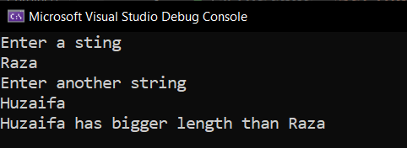

**Tasks: 04**

Write a program that takes a string as an input and copies it another empty string and displays it.

Code:

#include <iostream>

#include <string>

using namespace std;

int main()

{

string string1 ;

string string2 = "";

cout << "Enter a string: " ;

getline(cin, string1);

cout << "string1 before copying = " << string1 << endl

<< "string2 before copying = " << string2<<endl;

string2 = string1;

cout << "string1 after copying = " << string1 << endl

<< "string2 after copying = " << string2<<endl;

return 0;

}

Output:

